1. True or False? (2 marks per each correct answer, -1 mark per each incorrect answer, 0 mark per each blank)
1) A computer system is divided into three components: software, hardware, and users. ( )
2) Cooperative scheduling is necessary on the threads with non-preemptive scheduling. ( )
3) Modern operating systems run on the privileged mode in order to handle an incoming interrupt. ( )
4) The advantages of multi-threaded programming are responsiveness, resource sharing, economy, and scalability. ( )
5) A process can wait for the termination of its child by calling exec() system call. ( )
6) A user program can generate a trap. ( )
7) Two semaphores and two conditional variables are enough to implement the solution for the Readers-Writers problem. ( )
8) It is more convenient for application developers to use Application Programming Interfaces than to use system calls. ( )
9) The frequency curve of the duration of CPU bursts can be characterized as exponential or hyper-exponential with a large number of short CPU bursts and a small number of long CPU bursts. ( )
10) SJF algorithm is the optimal scheduling algorithm. ( )
11) Peterson’s solution is not guaranteed to work on modern computer architectures. ( )
12) A solution to the critical-section problem must satisfy the following three requirements: mutual exclusion, progress, and unbounded waiting. ( )
13) Liveness refers to a set of properties that a system must satisfy to ensure that processes make progress during their execution life cycle. ( )
14) The ‘synchronized’ keyword is related to the realization of monitor in Java ( ).
15) The advantage of the monolithic structure is its modularity. ( )

2. Explain two methods for inter-process communication including their advantages and disadvantages compared to each other. (8 marks)

3. Including the initial parent process, how many processes are created by the program shown below? Please describe the reason of your answer, too. (6 marks)
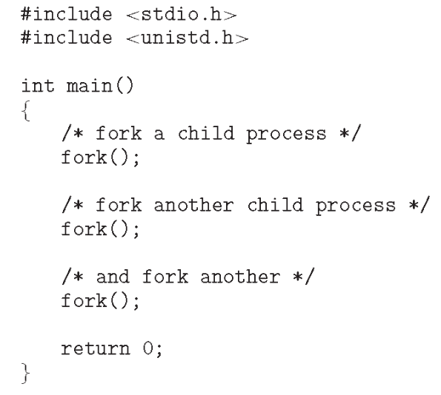

4. Explain the difference between user-level thread and kernel-level thread. (8 marks)

5. What is the purpose of interrupts? What are the differences between a trap and an interrupt? Can traps be generated intentionally by a user program? If so, for what purpose? (8 marks)

6. Fill the blanks in the following process state diagram. (10 marks – (# of incorrect answer or blank)*1mark), minimum 0 mark)
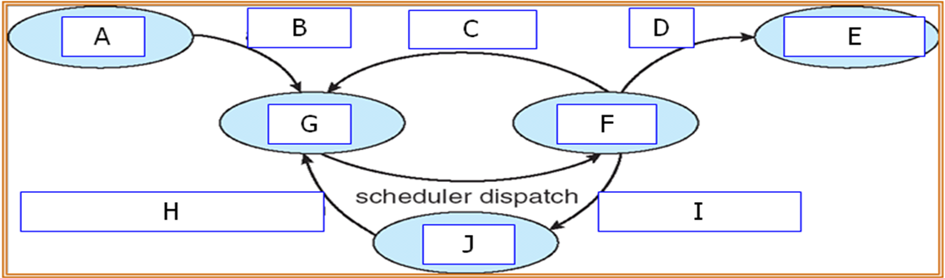

7. Explain process and thread, respectively. Your answer needs to focus on their differences from each other. (8 marks)
8. The following Processes are being scheduled using a preemptive, round robin scheduling algorithm. Each process is assigned a numerical priority, with a higher number indicating a higher relative priority. In addition to the processes listed below, the system also has an idle task (which consumes no CPU resources and is identified as P_{idle}). This task has priority 0 and is scheduled whenever the system has no other available processes to run. The length of a time quantum is 10 units. If a process is preempted by a higher-priority process, the preempted process is placed at the end of the queue.
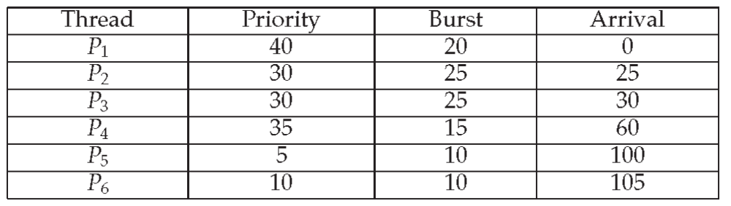
a. Show the scheduling order of the processes using a Gantt chart. (3 marks)

b. What is the turnaround time for each process? (2 marks)

c. What is the waiting time for each process? (2 marks)

d. What is the CPU utilization rate? (2 marks)

9. The following is a monitor solution to the dining-philosophers problem. Fill the blanks. (1 mark per each blank)

monitor DiningPhilosophers
{
enum {THINKING, HUNGRY, EATING} state[5];
condition self[5];

void pickup(int i) {
state[i] = HUNGRY;
test(i);
_________________________
_________________________
}

void putdown(int i) {
state[i] = THINKING;
________________________
________________________
}

void test( int i) {
if _______________________________________________________________________________ {
state[i] = EATING;
________________________________________
}
}
}

10. Describe the process to be performed when a system call is called in a user process. You need to focus on the change of the flow of control of execution and how the parameters and return value are passed. (7 marks)

